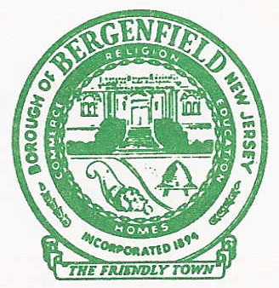
Office of the Tax Collector

BOROUGH OF BERGENFIELD
198 North Washington Avenue
Bergenfield, New Jersey 07621

(201)-387-4055 ext. 7
Fax (201) 385-7689

Tax Title Lien Redemption Information Sheet

Date of the request: ____________________

Tax Title Lien #: _______________________

Block: _______ Lot: _______ Qualifier: _______

Property Address: _______________________________, Bergenfield, NJ 07621

Requested redemption date: _______________________

Requesting person name: _________________________

Requesting person phone #: _______________________

Requesting person fax #: _________________________

Requesting person email: _________________________

- What is your legal interest in the property?

______________________________________________________________________________

______________________________________________________________________________

- Who will take custody of the certificate upon redemption (Name and address)?

______________________________________________________________________________

_________________________________
Print Name

_________________________________
Signature

Do not include current taxes due in the redemption check. Send Certified Funds ONLY.

